Node Js

Jre is platform to execute the java program it will not execute directly
Win32 is the platform to execute the c program
dot.net is the environment to execute the c-sharp program

Every environment need a engine to run the code

Chrome & safari uses v8 engine

//we can execute our js code directly as node filename
console.log("Hello NODE.JS")

Node js not supported with DOM cause DOM is related to browser so

Node is used for connecting with DB, file system, network, operating system

By Default node js has some packages/modules
In the js we called as libraries same as nodejs has modules

Node basically has process module (global package/ global object)
//will give us entire machine architecture details
console.log(process)
Pid is the id where our code execute with the id in the processor
Process obj has env to handle sensitive data

Node has 2 global consts
1.__dirname
2.__filename

1.will give u the current directory where we are executing our code folder path
2.will give u the current file name with folder structure(path with file name)
Except Process and global const we need to import all the node packages

Nodemon is the package once we install the nodemon we no need to restart our server after a small change nodemon will monitor the changes and restarting the server

1.fs(file system)
It Is the package/module has a multiple methods to handle the files
const fs = require("fs")
Fs has multiple methods to

read a file
Write a file
Delete a file
Update the data in file
Stats - Will give u the file entire details size etc

We have synchronous approach and asynchronous approach.
In the asynch also we have callback function and promise based function methods
const fs = require("fs")
const fsPromise = require("fs/promises")
We need import fs/promises for reading a file using promises
fsPromise.readFile("textfile.txt").then((data)=>{
console.log(data.toString())})

fs.rename("changingfilename.txt", "newfile.html", ()=>{})

console.log(fs.statSync("newfile.txt"))

2.path
Path module is need for handling the path
Path will give u the folder name, file name separately from our location
Will give u extension of file

3.url
Is used to get the info from the url

4.http
Website ?
Website is a collection of webpages in the web server
Why a website?
If we want to share the data throughout multiple users from a single end location.
Web server is a software installed in a computer, not all computers are web servers.
Communicating with web server through url
receiving the url request and giving the respected response is web server work
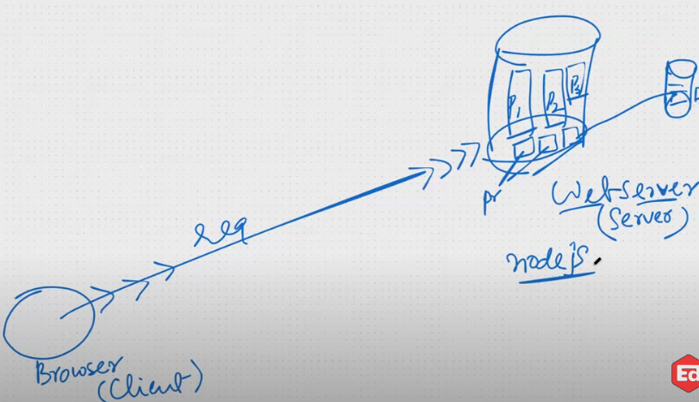
Node js is used to created a web server
Using http module in node js is used to create a server
http.createserver().listen(4000, ()=>{})
Every program need a environment to execute the code
Web application is a program which generates web pages
Server is just a function it will accept our request as a argument and our response is return
Database is a function
Operating system is a function
Web server is a function received request as a argument and returned response
Our request went to server call back function and call back function has 2 objects given by server
1 is request object and 2nd is response object
http.createServer(function(req, res){
console.log("Helloo") //printing console
res.write("Hellooo congratulations")
res.end()
}).listen(4000, function(){console.log("server is running")})
Req responsible for request, res responsible for given response
By default chrome will pass a request /favicon.ico when we pass default request /

Express js:
Express js is a framework

Why framework?
Framework will provide
scaffolding - give us folder structure,
availability - give us all the needed libraries,
security - ,
debugging -easy to find errors,
maintainability -easy to add/modify new features,
Performance - fast performance due to fast loading and fast development of application

Express is used to overcome the problems faced by node
1.when receiving the post request getting request data from user is not easy
2.can not execute the multiple programs single time
3.need to create multiple if else condition based on request url to multiple programs

Installing express framework using npm i express
After, express give us requires packages as node_modules
When we are passing data through params req received those as strings
And when we send a response we need to send as strings

When we are passing data through params server will give us in the req.params as an object

Middleware is the function
Express will give us some middlewares
We have internal. External middlewares

One of the middleware express providing is called static
Static is used to give the static files response without writing separate route

In the node we taken extension and req name and written if else to send static response to user
But in the express static middleware give us directly

When we are performing post call with form
That requested data is in the message body will get that data using body-parser middleware

Here 2 approaches we have
1 is through form - formEncodedFormat
2 is ajax call - jsonEncodedFormat

We have a module body-parser express will providing us a package/module to get the requested data when post call
Const boyParser = require(“body-parser”)
app.use(bodyParser.urlencoded({extended: false}))

When we are handling with post call with form, then the body-parser help us to pick the message body data update the req obj with body property filling with data
If we dont configure body-parser then the body property will not update in the req object

Web application is handling the requests from the user its developed by pre-defined routing for which request to give which response
app.use(bodyParse.json())

From BE its okay to mention only endpoint name
From FE we mentions complete api name with end point

Through form it will redirect
Through ajax call it will not redirect

MIDDLEWARES:
Express is also a middleware bw FE & DB
Express is doing handle the http requests, taking req & giving response
Middleware is a function which execute in between request and the route
Why?
Authenticating, security
If user logged middleware will check and if all good then it will execute the requested route by next() function
If user details not correct then middleware send the related response

We can configure middleware in 3 types
1.app.use(function(req, res, next){next()})
Default middleware
Execute for every request
2.app.get(“/route, function(req, res, next){next()}, function(req, res){res.send()})
Configuring between the route and handle function
Execute for specific route
3.function middleware(req, res, next){
next()
}
Declaring a function and configure between the route and handle function
Execute for specific route

We can configure multiple middlewares for single endpoint

Once middleware handle the response then it will stop by it self it will not allow to check another endpoints

Why body-parser middleware?
Body-parser middleware will check all the requests and if req object has the json data or form encoded data Then it will create the object with message body data
and create the body property and update the specific end-point request object with body property and insert the data into body property

body -parser will create the body property with form encoded data or json data from req object
And update the req object with body property

ROUTING:
Const router = express.Router()
router.get()
Module.exports = router

Routing is we can write separate routes based on the diff categories
And we can exports those routes from file
And import those routes in entry file server.js main

Const studentRoute = require(“../../)
app.use(“student”, studentRoute)

Template engine:

res.sendFIle if we give file path it will downloaded when respected end point executed

We can not use the code in the endpoint to display the ui for requests
Used template engine

Template engine works to give the ui from BE
Express will responsible for only giving the data based on the request

Pug is the library to use the generate the ui from BE

Cors and uploading

Why node js?

Using node js we can read file,processing with path, creating a server, how to handle a web server requests, how to send a files in the response, how to handle request parameters,

and express?
Creating an end points, creating a routes/endpoints in separate separate files and handle,
How to process a request and a response like how to get params and how to get message body in the post request, handling get requests, post requests,delete, put and patch req..
How to send a response for specific route
How to use pug files, template engines,
How to create and handle middlewares

Our server running on the 4000 port if we want to send a request from another origin port like 3000 or 2000 or our local html file ports the backend server will block the request coming from other domain requests

When request comes from another port the 4000 port the backend server will block the other origin requests

Cors-policy:domain origin resources we can only access the requests when it will come from the same domain, default
If we set up cors middleware in our BE the blocking error will get erased
Npm i cors
Const cors = require(“cors”)
app.use(cors())
When we set the cors, for every req the middleware add the cors headers and pass to the request

Cors options
app.use(cors({
origin: 'http://localhost:3000',
optionsSuccessStatus: 200 // some legacy browsers (IE11, various SmartTVs) choke on 204
}
))
We can set up the preferred servers to access our server, only 3000 server can access our BE server
If we want to increase our permissions we can past the urls in the array

Http-server give u the temp server, it could run our project on the temp server

app.use(cors({
origin: ['http://localhost:3000',http://localhost:4000]
optionsSuccessStatus: 200 // some legacy browsers (IE11, various SmartTVs) choke on 204
}
))
Both the origins can able to access the BE server

When we are posting the data and files from form we can use another method like enctype=”multipart/form-data”(encoded type)
Then server considered multipart data

Body-parser is used to get the data from message body from the req and create the body property and inserts data into that body

When we are posting the data from form using multipart the body will give us an empty object cause the body-parser could not find the data
When we are dealing with the multipart data the multer help us to get the data from the body
const multer = require('multer')
const upload = multer({ dest: 'uploads/' })
app.post('/profile', upload.single('avatar'), function (req, res, next) {
})
Need to create a folder called uploaded
Once we setup the multer we can able get the form data excepts files
For files we can get able to get from the file property
Multer can create a property called file and take the file from req and put into the file property
Multer middleware will receive the multipart data and place the form data into body & files into file property
Also that file uploaded into the upload folder with random name cause we setup the destination as uploaded
That file name called temporary file name
Mongo db:
Mongo db is nothing but a javascript object
Mongo db has cloud setup and local set up by installing a compass
DBMS(database management system) & DB(database)
WINDOWS & FOLDER
The dbms & db is the relation like os and folder
Dbms is the software to create db,s we can create plenty of db’s
Db is the collection of data
DBMS are 2 types
1, RDBMS & 2,NO SQL/Document System
MongoDB is the DBMS
oracle,sql server, my sql, mongo db, post gray, maria db are the DBMS’s
Mongo db doesn't have any structure schema
RDBMS are the strict follow structure schema
dataBase Name
Collections
Data maintained as a document and automatically generated ID
We can enter data manually in the DB and instead of manual we can insert data by using mongoDb queries through shell
Need to install mongodb compass local set up
In the cluster we have options to connect through compass and drivers both are provided link to connect

Mongo db CRUD Operations players:

Cookies:
Npm i cookie-parser to get the cookies values from the req and create a cookies object and place the values into cookies object.
Cookies -> sessions->tokens are mainly used for authentications.
Web application: the communication between browser and web server
The communication over happened as req and response
When we request through browser web server give a response as a web page is web application
Handling req from the browser and give a respected response to the clint is web application
Returning web page as a response done by web application
When if the response page is static so it's called website
When if the response as dynamic then its called web application
When the response is page then its a web application
When the response is the data then its called webApi(web services)
Web application programming interface
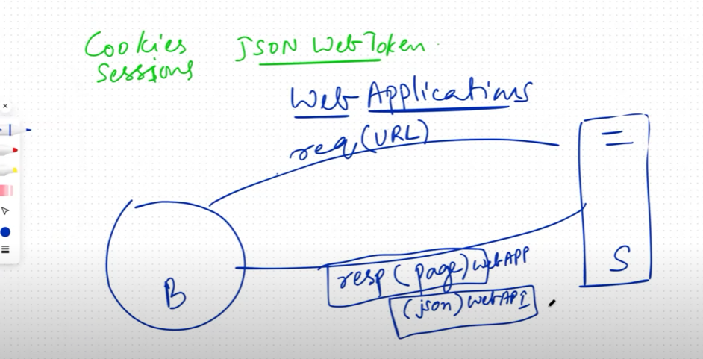
What are the alternatives for rest api?
Soap and xml rpc
What is the difference bw rest and xml rpc?
Both are the soap are used access the web service / web api for particular endpoint
Sometimes server will send the details as cookies and browser will store that cookies
Cookie is a key and value pair (key: value)
When we are sending req to the server with some url then server will send some details as cookies and send in the response
And when we are sending req to that particular url then this cookies also send in the req to that url
If we have cookies for some specific url then tat cookies will go in the req
If we don't have cookies then server will send in the req then browser will store then from every req that cookies are also go to the server
Server create the cookies and send in the response
Cookies will go to the specific domain only every domain has its own cookies
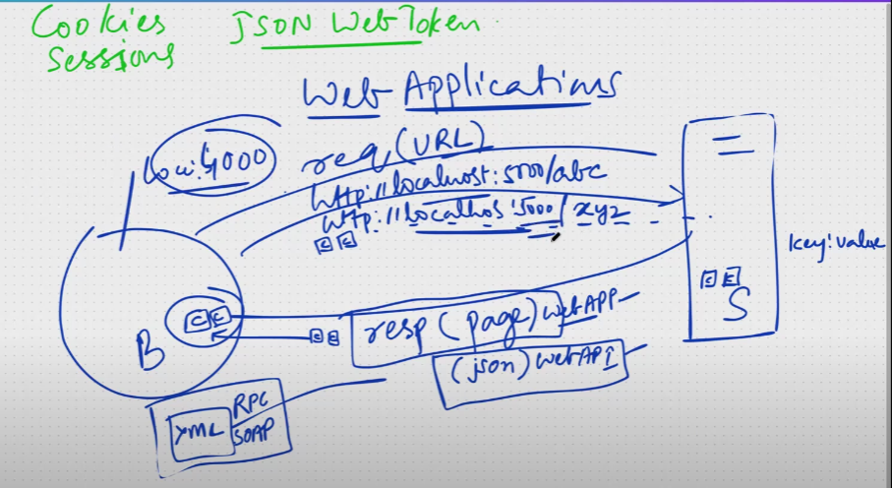

We only send the cookies from the server as
res.cookie(“username: req.body.username)
So the cookie will comes to browser and save under the cookies
So for every route the req will send the cookies in the req we can see in the middleware
We can check with db and set cookie in the browser and setup middleware to if cookies then next or simply login to login page

Express-session handling:
We are maintaining the client details in the cookies for authentication
Sessions are more security then cookies we no need to save the password things in the browser just simply with session id
Npm i express-session
When we configure the express-session({secret: “Hw”})
In the cookies one secret id configures how many tabs opened the id same for all tabs
That id changes based on the browser
We can declaring the count variable and trying to see the attempts count
So if we open the another new browser it will continue the count value
If we restart the server then count starts from 0
The browsers maintained a session id as different
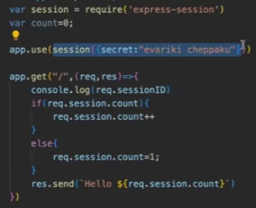
Session maintained by separate browsers
Express-session middleware help us to maintain a different sessions for diff browsers
Default session id created in the cookie so if w close and open the browser again it will continue from where your left

Express-jsonwebtoken
The cookies and sessions are works on the 4000 br server so comes to the react react runs on the 3000 port server FE and BE running on the diff servers
So BE server will give to FE server a token
When we are trying to get the response from BE we need to set up cors() otherwise will get corsing error
Jsonwebtoken
jsw.sign(req.body, “secret key”)

